
User Manual for Practitioners to send a request for CPD update

The Purpose of the Manual is to guide Health Practitioners on how to raise an incident to update CPD points on OSVC Portal.

- Go to the HPCSA website www.hpcsa.co.za
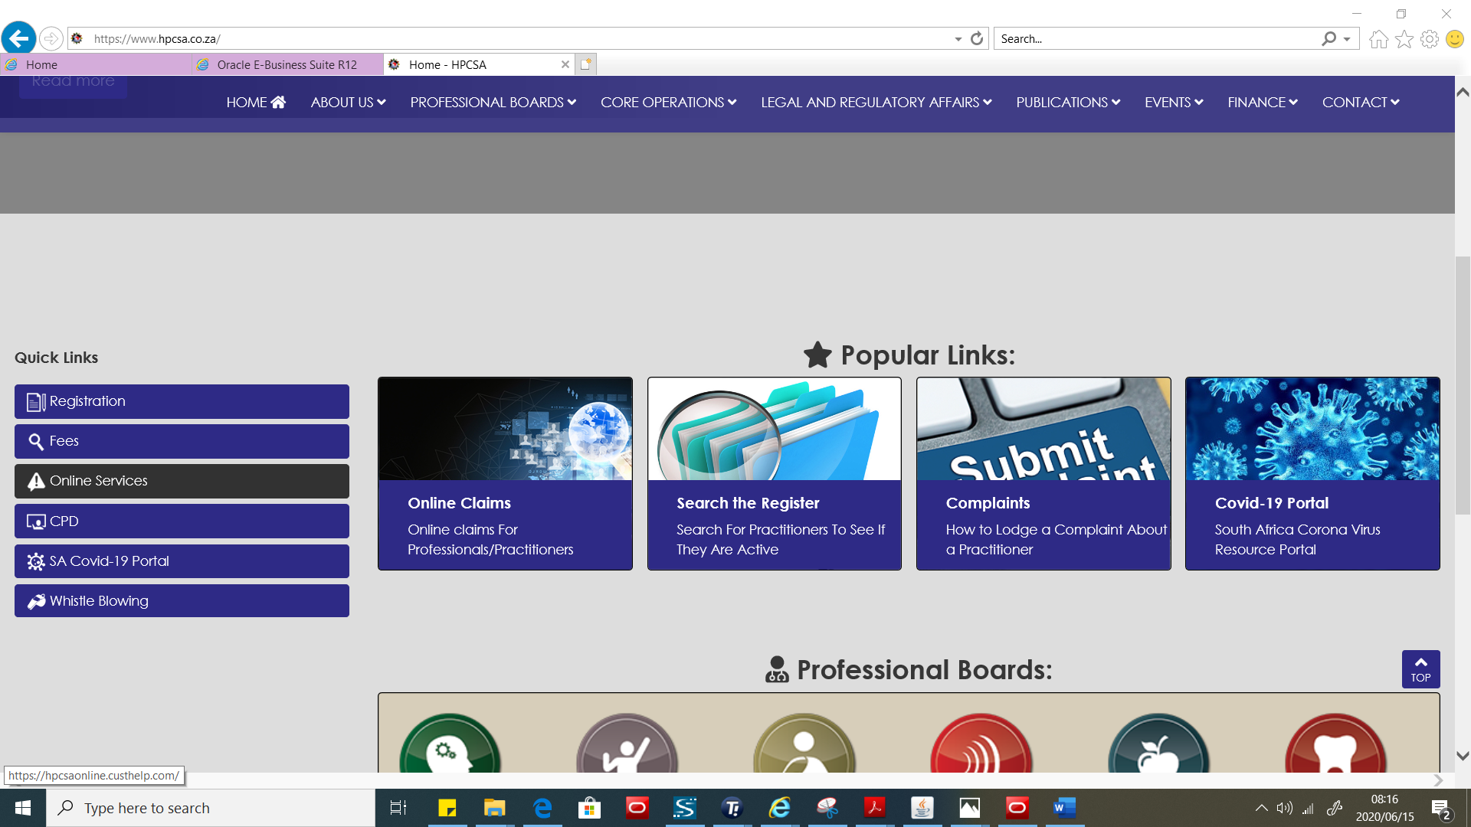
- Click on Online services and the below page will be displayed.
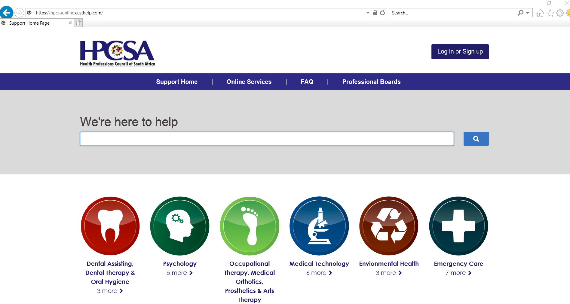

- Please note All registered practitioners has been assigned accounts please do not create a new account. If a practitioner has not logged on the portal before click on the login or sign up button.
- If a practitioner has logged in before He\She must capture the username and password.

- If practitioner has not logged in on the system before they need to Click on the Forgot username or Password link
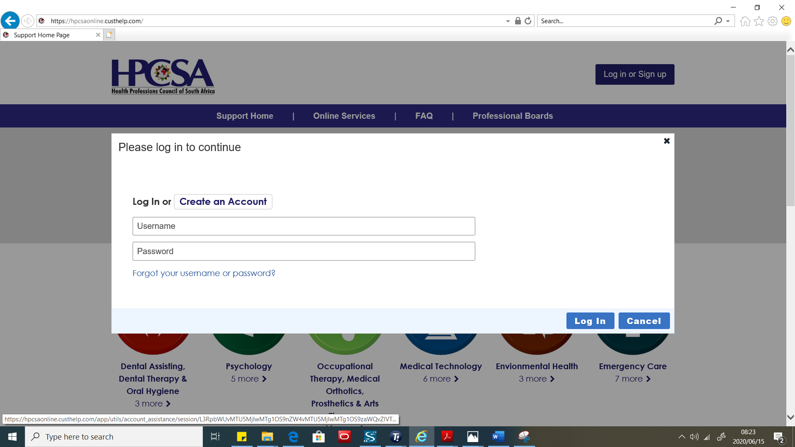
Please note the username is the practitioner’s ID number or passport number.
- Type Practitioner ID number or passport below Username and click on the button Reset My password. An email will be sent to the registered email address and an SMS will be sent to the registered cell number. 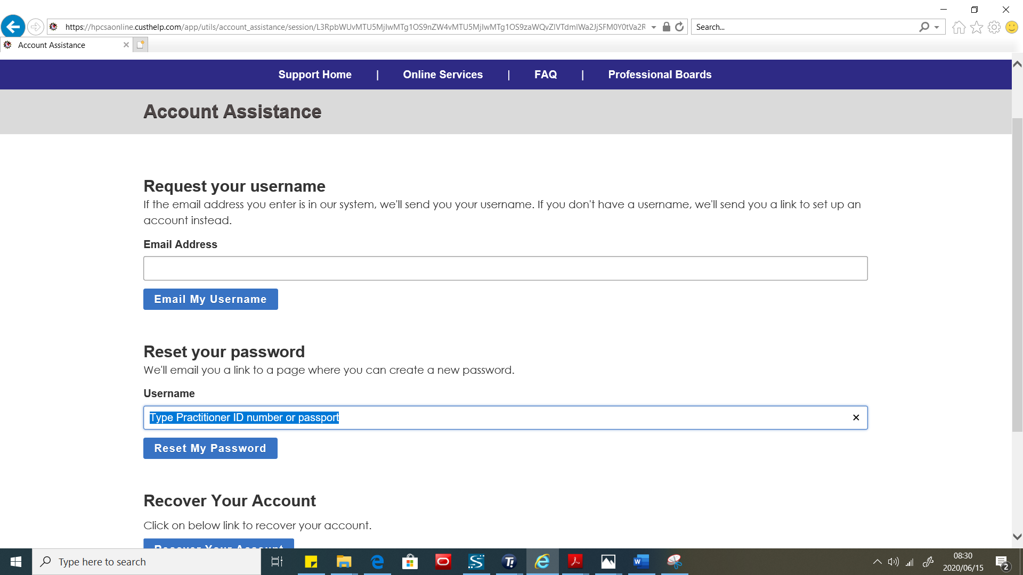
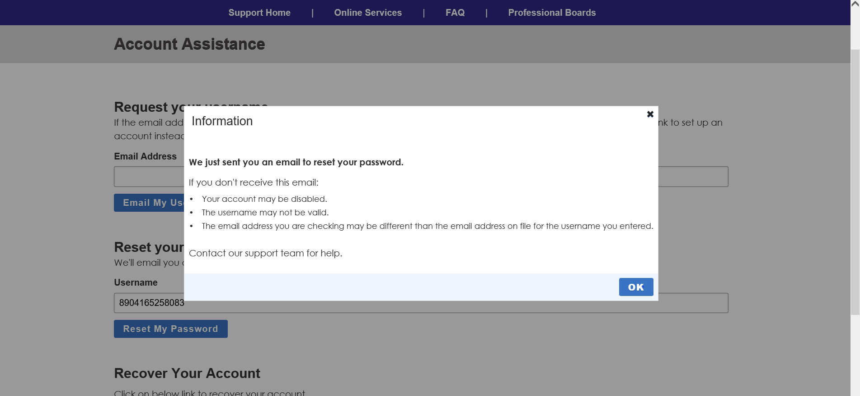
- If you don’t receive any communication click on the Recover Account button.
- The email or sms will be having a link to reset your password and you will have to type the password and verify it. An example of a strong password that can be used is #Password1
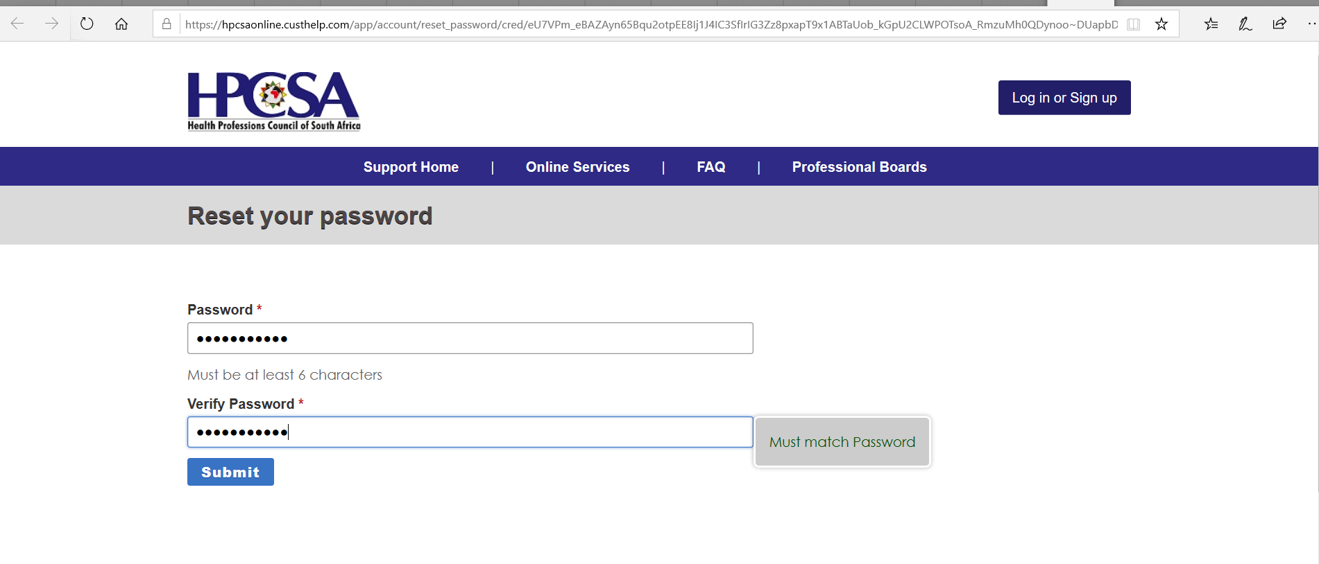9. After successful login the below page will be displayed. Check if details are correct and click save changes
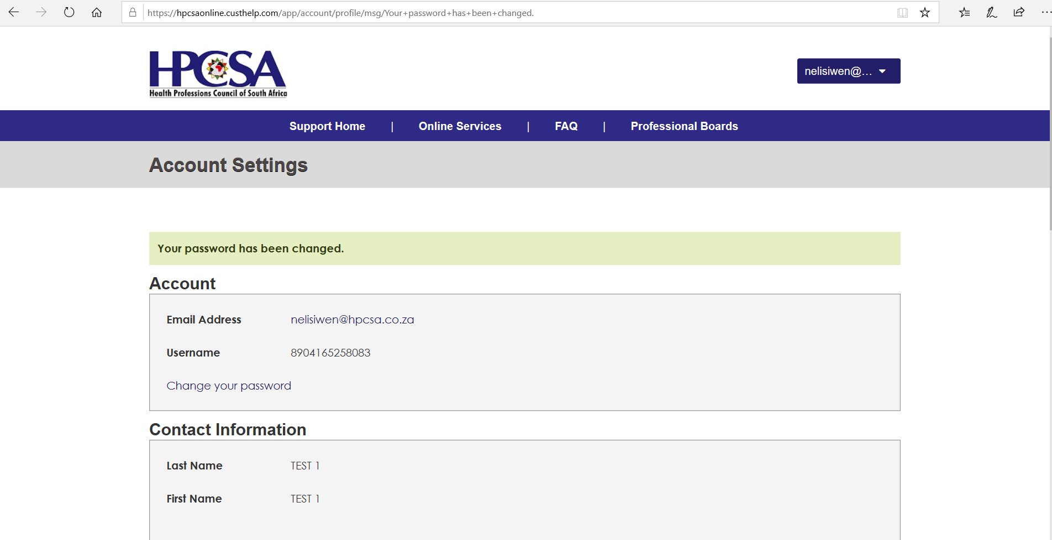
13. click on the top right where your name will be displayed and click on the arrow and select Account overview
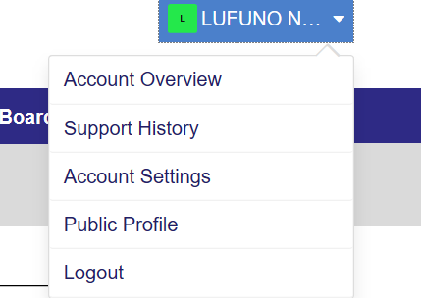
14. After clicking on Account Overview click on My CPD’s as shown below
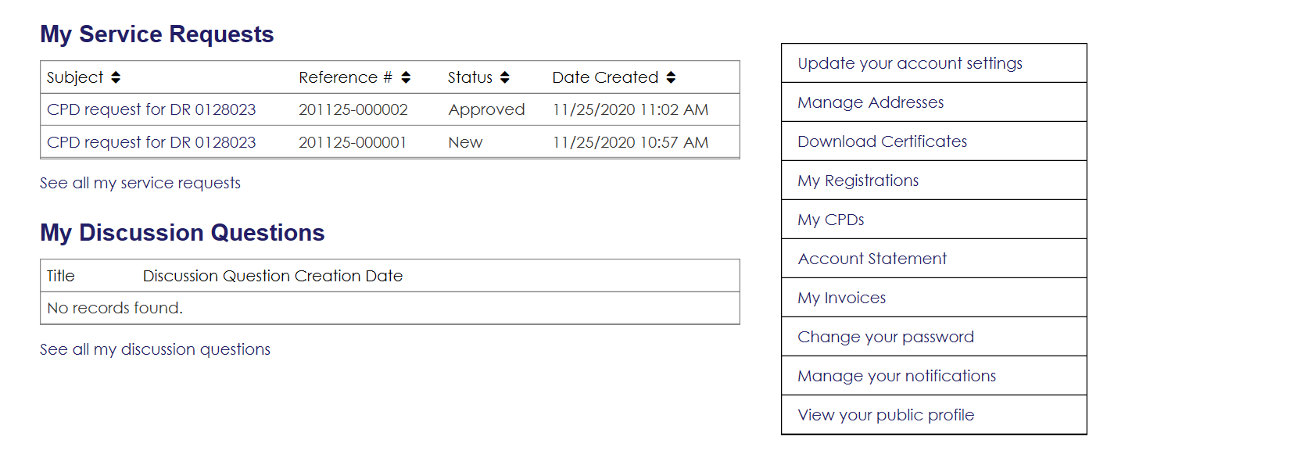
15. After clicking My CPDs 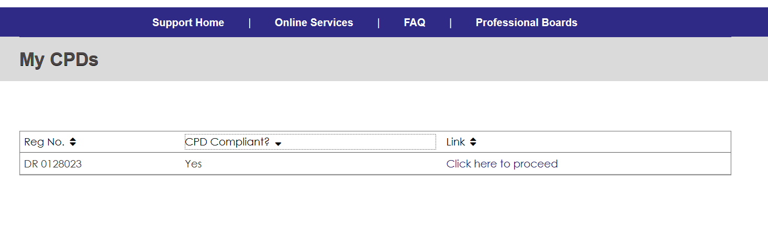
A Screen showing a summary of CPD activity will be shown. If registration is CPD compliant the option to download compliance letter will be enabled.
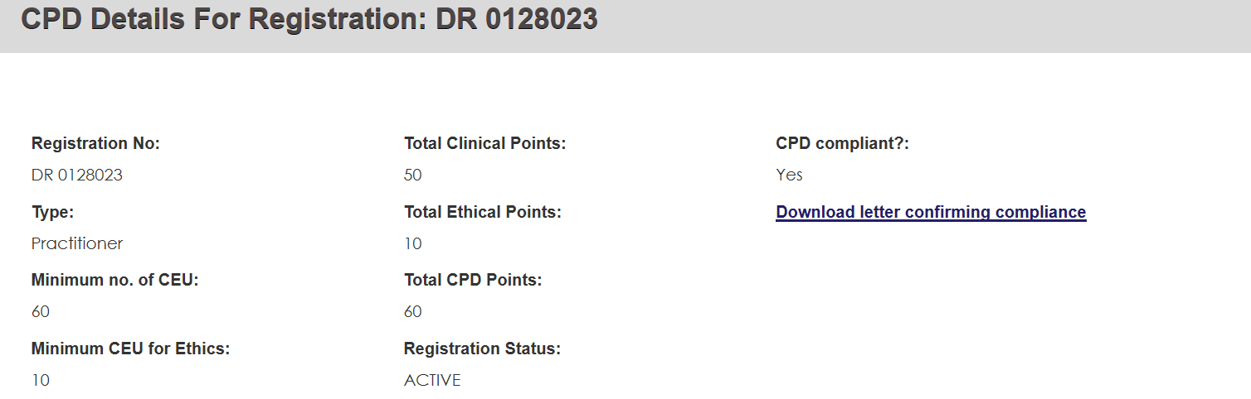
16. Click on click here to proceed then you may click the button Add new CPD 
17. A form to add details will be shown as below
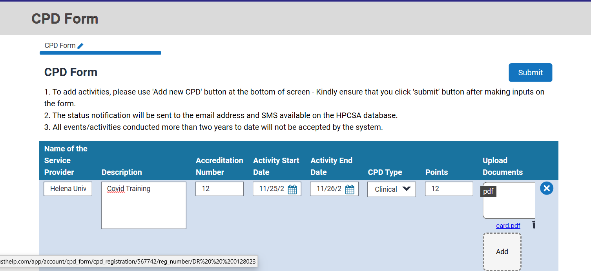
18. After clicking the Submit button, the Service request number shall be generated
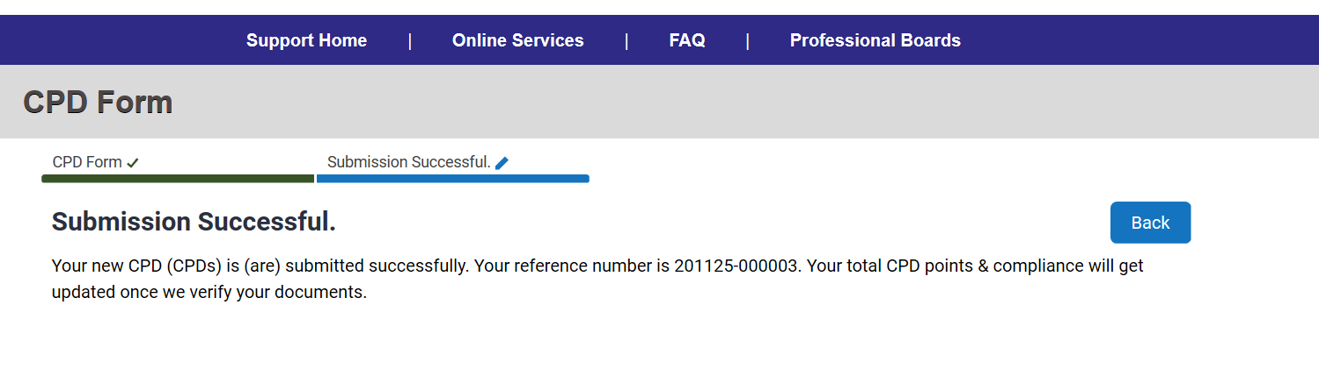
19. To check If the request has been resolved. Click Support History.

